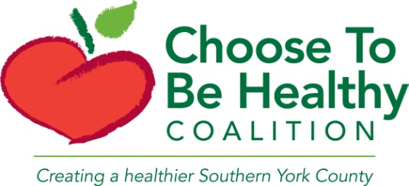
Coalition Meeting
Thursday, March 17th
3:30-5PM
The Coastal House, Wells, Maine
Meeting Minutes

- Updates from Staff
  - The Drug-Free Communities grant application that we have been working on was submitted on Monday. We are hoping to receive this federal funding for the next 5 years to help support local substance abuse prevention efforts
  - DITEP (Drug Impairement Training for Educational Professionals) training was held at Marshwood High School Tuesday and Wednesday this week with a good turnout. Those in attendance included School Resource Officers, Guidance Counselors, and Administration.
  - We have completed Rural Active Living Assessments for all 9 towns. We would like to recognize the following 3 towns for their commitment to active living and present them with bike racks: Ogunquit, York, and South Berwick.
- Amy Bouchard, Let’s Go 5210
  - The Let’s Go program focused on changing enviornment/policies in:
    - Childcares
    - Schools
    - Workplace
    - Communities
    - Out of schools
    - Healthcare
  - 5210 stands for:
    - 5 or more fruits and vegetables
    - 2 hours or less recreational screen time
    - 1 hour or more of physical activity
    - 0 sugary drinks, more water
  - Contact: arbouchard@smhc.org
- Abby King, Bicycle Coalition of Maine
  - Advocacy and education nonprofit
  - What do we offer?
    - Trainings
    - Events
    - Webinars
    - Technical assistance
    - Connecting people
    - Connecting the dots
    - Online toolkit
    - Policy help
  - Community spokes
    - Statewide group of over 100 champions
    - Represent all 16 counties
    - 2 trainings/year, next training: May in Washington county
  - Don’t have to be experts to be advocates!
  - Contact: abby@bikemaine.org
- Karen Young, Mount A to the Sea
  - Coalition of 10 conservation association in Southernmost towns in York County
  - Websites: www.mta2c.org and gatewaytomaineoutside.org
  - Goal: engage new audiences and more people
    - Mental health and physical benefits
    - Children and families
    - Physically disabled
      - Universal access trail
    - Underserved and under resourced
    - Seniors
  - Contact: kyoung@mta2c.org
Discussion
- Collaboration ideas
  - Farmer’s Market in York offers table to nonprofit agency to showcase work
  - Chamber of Commerce in York needs help with parking for bicyclists leaving cars
  - We should all meet for a walk/bike ride. Could involve local legislators. Possible date: June 4th after the York Hospital 5K
- Other ideas
  - Assisted living/senior centers
    - More universal access trails
    - Someone could draft sheet of active opportunities/resources and give to activity directors
    - Outreach to these groups to get them involved. Work with AARP?
  - Need for signs that encourage walking in promotion of activity
    - Resource: www.walkyourcity.org
    - Can order/customize signs to promote physical activity in your town
  - Physical activity and youth
    - Can be a protective factor
    - Promote healthy activities and well being
  - Need more education about bike rules
  - Economic development
    - Get people moving, who will get healthier and possibly spend money in the process
  - Traffic concerns

