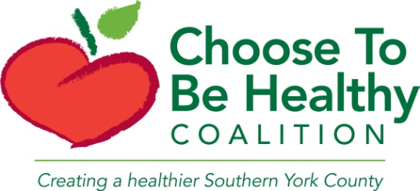
Coalition Meeting
Thursday, November 12, 2015
11AM-1PM
York Hospital TMR
Meeting Minutes

Present: Rick Varney, Noble HS; Jean Mitchell, York County Community College; April Powell, York County; Tim Ericson, Wells HS; Jack Moran, CTBH Advisory Board; Todd Bayha, Wells PD; Glenn Dochtermann, Dept of Conservation; Diana Kelly, Home Instead; Cheria Clow Rollins, York Hospital; Deane Rykerson, Kittery Rep; Karen Boardman, CTBH Advisory Board; Maryann Anderson, York HS; Janice Johnson, Massabesic HS; Deirdre Thompson, YCCC, Karl Thompson, community member
- Updates from CTBH
  - Reminder that we are a community health coalition that works on tobacco, obesity and substance abuse initiatives
  - Obesity treatment program: finished first session of class the end of October and started new class in Kittery on November 3rd. Will be starting 3rd session in January and hope to do a session for teens starting in March in Wells at Wells HS.
  - Substance Abuse Prevention:
    - Sally has been appointed to an opiate task force (made up of 3 sub groups) convened by the Maine Attorney General’s office. She is on the harm reduction/prevention group. The task force will be conducting listening sessions at a later date. Stay tuned for how you can get involved.
    - We have invited juvenile justice and local treatment providers to our regional law enforcement team meeting on November 19th. We will be discussing developing protocol for helping youth and adults with substance abuse and mental health conditions.
    - Contact Michelle at mmason@yorkhospital.com if you work with pregnant women or young parents and would like a presentation or resources around prenatal substance exposure or safe storage of medication
- RALA, e-cig, grant applications, YCCC, event applications
  - Putting together South Berwick Rural Active Living Assessment (RALA) and Lebanon is in the works. If you live in either of these towns and would like to help, contact Devin at drowe@yorkhospital.com
  - Have submitted Maine Cancer Foundation grant application for e-cigarette education campaign funding. Will find out in the next few months if we will be funded.
  - CTBH will sponsor tobacco-free events. Contact Devin for an application.
- Bangor Public Health videos
  - Bangor Public Health just released 2 PSAs about e-cigarettes, one geared towards youth and one towards adults. Visit www.bangorpublichealth.org to view them
- Amber Desrosiers from the Attorney General’s Office on Tobacco Control
  - October 15th, 2015—LD 1108: revised smoking law
  - January 1st, 2016: child protective law in Maine
  - Contact Amber with compliance concerns at amber.desrosiers@maine.gov or visit www.tobaccofreemaine.org and file a tobacco violation complaint form.

